|  |
| --- |
| Name: Wedamulla Madusanka |
| Student Reference Number:10899603 |



|  |  |  |
| --- | --- | --- |
| Module Code: PUSL2023 | Module Name: Mobile Application Development | |
| Coursework Title: Coursework Project Proposal Documentation | | |
| Deadline Date: 19/02/2024 | | Member of staff responsible for coursework:  Mr. Diluka Wijesinghe |
| Programme: BSc Honors Software Engineering | | |
| Please note that University Academic Regulations are available under Rules and Regulations on the University website [www.plymouth.ac.uk/studenthandbook](http://www.plymouth.ac.uk/studenthandbook). | | |
| Group work: please list all names of all participants formally associated with this work and state whether the work was undertaken alone or as part of a team. Please note you may be required to identify individual responsibility for component parts.  10899603 – Wedamulla Madinage Thisara Madusanka  10899621- Chathupraba Devindi Munasinghe  10899521 – Navindu Nimsara Gamage  10899556- Yaddehi Kishal Sankalpa Jayalath  10899685- Kihaduwage Diduli Wijini Sahasra  10899600- Senanayake Dasili Liyanage Sameepa Pramuditha  ***We confirm that we have read and understood the Plymouth University regulations relating to Assessment Offences and that we are aware of the possible penalties for any breach of these regulations. We confirm that this is the independent work of the group.***    Signed on behalf of the group: | | |
| Individual assignment: ***I confirm that I have read and understood the Plymouth University regulations relating to Assessment Offences and that I am aware of the possible penalties for any breach of these regulations. I confirm that this is my own independent work.***  Signed : | | |
| Use of translation software: failure to declare that translation software or a similar writing aid has been used will be treated as an assessment offence.  I *have used/not used translation software.  If used, please state name of software………………………………………………………………… | | |
| **Overall mark _____% Assessors Initials ______ Date_________** | | |

|  |  |  |  |  |  |  |  |  |  |  |  |  |  |  |  |
| --- | --- | --- | --- | --- | --- | --- | --- | --- | --- | --- | --- | --- | --- | --- | --- |
| Social-Media Application Development | Project Proposal  PUSL2023-Mobile Application Development  Group 121  **Group Members**   |  |  | | --- | --- | | Plymouth ID | Student Name | | **10899603** | Wedamulla Madusanka | | **10899621** | Chathupraba Munasinghe | | **10899521** | Badal Gamage | | **10899685** | Kihaduwage Sahasra | | **10899600** | Senanayake Liyanage | | **10899556** | Kishal Jayalath | |

Table of Contents

Introduction 3

Problem Definition 4

Scope of the Project 5

Objectives 6

Features of Application 7

Wireframe diagrams 9

Work Matrix and Gant chart 11

Reference List 12

# Introduction

In the current digital era, social media has completely changed the way we interact, communicate, and exchange information in our everyday lives. But even with so many social media platforms already in place, there is still a fundamental challenge to be solved: there isn't a single, all-encompassing solution that prioritizes privacy, security, and user experience while also efficiently catering to the wide range of demands and preferences of users.

We plan to address this issue by creating a new mobile application that serves as a next-generation social media platform, bridging the gap between current platforms and user expectations. The program aims to provide users worldwide with a smooth and captivating social networking experience by utilizing state-of-the-art technology and creative features.

The application's scope is carefully set to include a broad variety of capabilities that appeal to different user demographics and interests. Every feature of the app, including real-time chat, sophisticated privacy settings, interactive content creation tools, and configurable user profiles, has been thoughtfully designed to satisfy the changing needs of contemporary social media users.

Moreover, the suggested application has substantial economic and industrial potential in addition to its inherent usefulness as a social networking tool. The app offers companies, marketers, and advertising attractive options to contact their target audiences in a more relevant and customized way because of its capacity to draw in and keep a sizable user base. Its economic worth is further increased by the extensive data insights the platform generates, which provide priceless market research and analytics capabilities.

In conclusion, our suggested social media application not only solves a critical gap in the current digital environment, but it also offers a strong chance for creativity and economic success. With a focus on user-centric design, strong functionality, and business viability, we want to revolutionize the social media landscape and position our app as a market leader.

# Problem Definition

The inability of current platforms to satisfy the wide range of user demands and expectations is the central theme of the issue definition for the suggested social media application. User experience, data security, privacy, and content moderation are among the many issues that users face despite the multitude of social media platforms at their disposal.

The absence of extensive privacy options on current platforms may result in the exposing of undesired content or possible compromises of personal information. It might also be difficult for users to efficiently manage their social connections and interactions or to navigate through busy interfaces.

Furthermore, it is extremely difficult to maintain a secure and encouraging environment for users to communicate and engage due to the widespread spread of false information, malicious material, and fake news. Moreover, the commercialization of social media frequently leads to data exploitation or obtrusive advertising tactics, which erode user contentment and confidence.

The characterization of the problem essentially revolves around the requirement for a new social media platform that proactively tackles these problems by providing improved privacy protections, powerful content moderation tools, user-friendly interfaces, and open data rules. The suggested program seeks to address these issues in order to give users a more satisfying, safe, and joyful social networking experience.

# Scope of the Project

The project's scope includes developing a full-featured mobile social networking application with an emphasis on providing a user-friendly, safe, and interesting experience. Tailored user accounts, real-time messaging, extensive privacy settings, interactive content creation tools, and sophisticated content control methods are some of the key features. Users of the program will be able to import contacts and easily connect with friends thanks to its flawless connection with current social media platforms. In order to provide insightful information about user activity and preferences, the scope also includes the use of data analytics capabilities. Ensuring optimal performance and customer satisfaction will need extensive testing across numerous platforms and revisions based on user feedback, as part of this project.

The overall goal of the scope is to provide a flexible social networking site that satisfies a wide range of user demands while maintaining the greatest levels of usability, security, and privacy.

# Objectives

The objectives of the application are multi-faceted:

1. Privacy and Security: To provide a secure and reliable online environment, give top priority to user privacy and security by putting in place strong data encryption, detailed privacy controls, and proactive content moderation systems.
2. User Engagement: To increase user satisfaction and retention, promote active user engagement with personalized content creation tools, interactive features, and intuitive design.
3. Community Building: Encourage inclusive user interactions, promote a variety of content types, and provide users the freedom to express themselves honestly in order to develop meaningful connections and community building.
4. Scalability and Performance: Use scalable infrastructure, maximize code efficiency, and carry out thorough testing on a range of platforms and devices to guarantee scalability and flawless performance.
5. Market Differentiation: Set the application apart from other social media platforms in the market by providing special features, cutting-edge functionality, and an improved user experience that is catered to the changing demands and tastes of contemporary users.
6. Financial Viability: Maintain user-centricity and ethical data practices while achieving financial success through targeted advertising possibilities, effective monetization tactics, and collaborations with brands and companies.

The application's overall goals are to become a premier social media network that not only meets but beyond user expectations and provides real value to stakeholders and users alike.

# Features of Application

Followings are the basic features we are planning to use in the application:

1. **Personalized User Profiles:**

* Permit users to add interests, biographies, and profile images to make their profiles unique.

1. **Tools for Creating Interactive Content:**

* Give users a range of resources to produce and distribute interesting material, including images, videos, narratives, and live broadcasts.

1. **Instant Messaging:**

* Allow users to share multimedia and engage in private messages and group discussions with ease.

1. **Strong Privacy Configurations:**

* Give users precise control over their privacy preferences, allowing them to see who can see their posts, who can see their profile information, and who can target their audience.

1. **Notification Mechanism:**

* Establish a notification system to alert users in real time about likes, comments, mentions, and other pertinent activity.

1. **Advanced Moderation of Content:**

* Use AI-powered content moderation technologies to identify and remove hate speech, spam, and other objectionable information, providing a secure and friendly environment for users.

1. **Smooth Integration:**

* Enable smooth interaction with other social media networks so users may import contacts and establish connections with friends from different networks.

1. **Data-driven insights:**

* With thorough data analytics, give administrators and users insightful information about audience demographics, content performance, and user engagement.

1. **Platform Interoperability:**

* Make sure that the user experience is consistent and compatible with a variety of platforms, such as web browsers, iOS, and Android.

1. **Characteristics of Accessibility:**

* To accommodate users with different needs, including accessibility features like font size adjustments and screen reader compatibility.

Together, these elements seek to provide a vibrant, user-focused social media environment that values security and privacy for users while promoting deep relationships and innovation.

# Wireframe diagrams

Figure 4

Figure 3

Figure 2

Figure 1

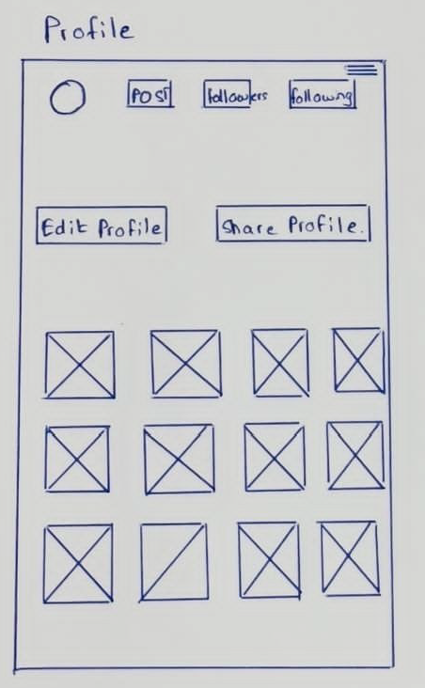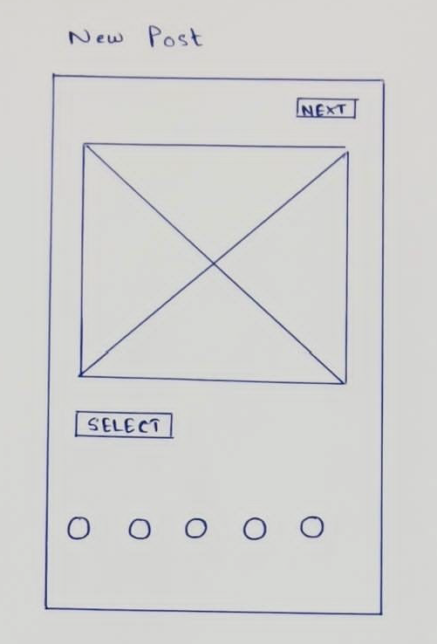

Figure 6

Figure 5

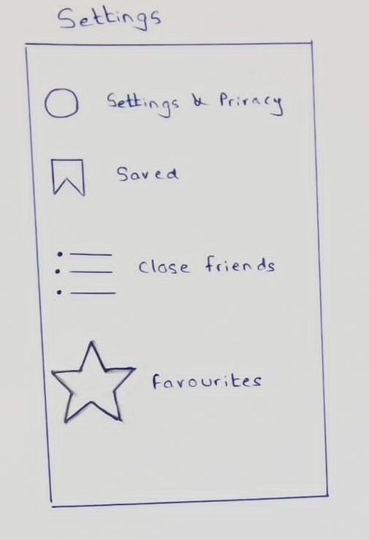

Figure 7

# Work Matrix and Grantt Chart.

Work Matrix:

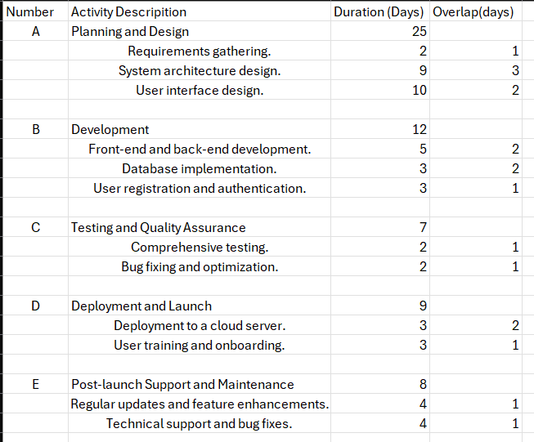

Figure 8

Figure 9

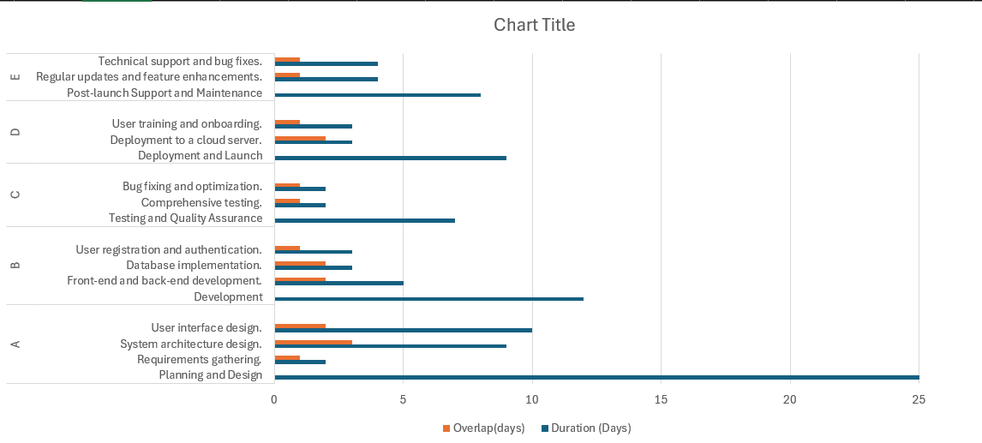Grantt Chart:

# Reference List

Patel, B. (2023) *Step-by-step complete guide to create Social Media App*, *Brainvire.com*. Available at: <https://www.brainvire.com/blog/create-your-own-social-media-app/#:~:text=Some%20of%20the%20steps%20involved,launching%20and%20marketing%20the%20app> . (Accessed: 16 February 2024).

Mousavi, Reza & Chen, Rui & Kim, Dan & Chen, Kuanchin. (2020). Effectiveness of privacy assurance mechanisms in users' privacy protection on social networking sites from the perspective of protection motivation theory. Decision Support Systems. 135. 113323. 10.1016/j.dss.2020.113323.

Savenko, N. (2022) *Social Media Application Development: Features, costs, compliance*, *Your ultimate guide for social media application development.* Available at: <https://www.voypost.com/blog/social-media-app-development> (Accessed: 15 February 2024).

*How to make a social media app: Development guide 2024* (no date) *Addevice*. Available at: <https://www.addevice.io/blog/how-to-make-a-social-media-app> (Accessed: 19 February 2024).